PRESS RELEASE
More details: robert.minhinnick@sustainablewales.org.uk
EMBARGO until November 2nd 2021 Tel. 01656 773627

https://www.sustainablewales.org.uk/gorwelionhome
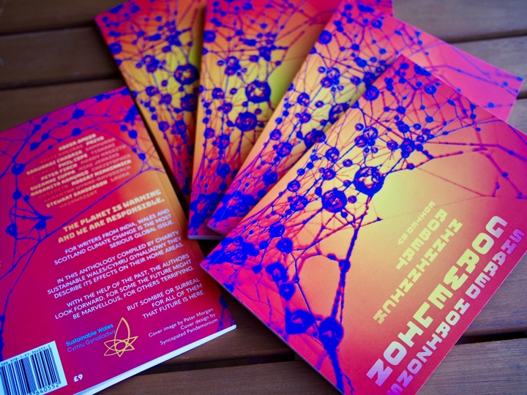
(logo files etc. available for download on this page)

‘GORWELION:SHARED HORIZONS’

New anthology published during COP26

From Sustainable Wales Cymru Gynaliadwy & Parthian Books.

The planet is warming and we are responsible. This means the Climate Crisis Requires ‘Blitz Spirit’.

For 16 writers from India, Wales and Scotland climate change is the most serious global issue.

They describe its effects on their home areas.

With the help of the past, they look forward. For some the future might be marvellous, for others terrifying.

Nine writers from Wales, two from Scotland and five from India have been enlisted by the charity Sustainable Wales Cymru Gynaliadwy to produce an original anthology that describes the present and possible futures of their home areas.

Writer, Robert Minhinnick, joint founder of Friends of the Earth Cymru and Sustainable Wales, has edited the volume.

He claims “Climate change is the most important issue we face. For us it is D Day and The Blitz. This climate crisis means that we need nothing less than a Blitz spirit.

We are especially pleased that rarely celebrated Welsh locations such as Blaengarw, Aberangell and Newport’s Ringlands are featured in the volume.”

Welsh Writers also include Peter Finch, Laura Wainwright, Phil Cope, Samantha Rhydderch.

Meanwhile, Sampurna Chattarji, who has edited the Indian section, writes:

"In light of the damage that we are doing to the planet, our “Gorwelion Shared Horizons project” gains a significance that is truly profound.”

The first live events for the anthology occur in Porthcawl, November 5th and December 3rd; Brecon November 19th, and then a host of Welsh events in the New Year. Details from Sustainable Wales.

The Authors: Abeer Ameer Aditi Angiras Priya Sarukkai Chabria
Sampurna Chatterji Phil Cope Tishani Doshi
Peter Finch Mandy Haggith Suzanne Iuppa
Mike Jenkins Nabanita Kanungo Christopher Meredith
Robert Minhinnick Samantha Wynne-Rhydderch
Stewart Sanderson Laura Wainwright

